**Kratin Application**

**Problem Statement:**

Identify one use case for elderly care (for the age group 65+) using technology and create working prototype .

**Solution:**

According to National Council on Aging, 92% of seniors have at least one chronic disease and 77% have at least two.

Heart disease, stroke, cancer, diabetes and Calcium Deficiency are the major problem that occur in most of the people at the age of 65+ and above.

To solve this problem, I have chosen one major problem that is calcium deficiency.

**Calcium Deficiency:**

Calcium is required for proper muscle contraction, including those within the walls of blood vessels. It is used to secrete hormones and enzymes in the body. Calcium is also needed to send messages to the brain through the nervous system using neurotransmitters. It helps in maintaining a steady heartbeat. It transports ions across the cellular membranes. A number of the body’s functions depend on having enough calcium.

The amount of calcium required by a person depends primarily on the age. Children need more calcium as their skeletal structures are still growing. Older women need to take more calcium as they may be at risk for osteoporosis. Those suffering from certain medical conditions may also be asked to step up their calcium intake.

**Idea through technology:**

The Angular application is developed which contain the home page, Register, Diet Plan, Diet Value, Add Diet, My Diet.

1. **Home Page**

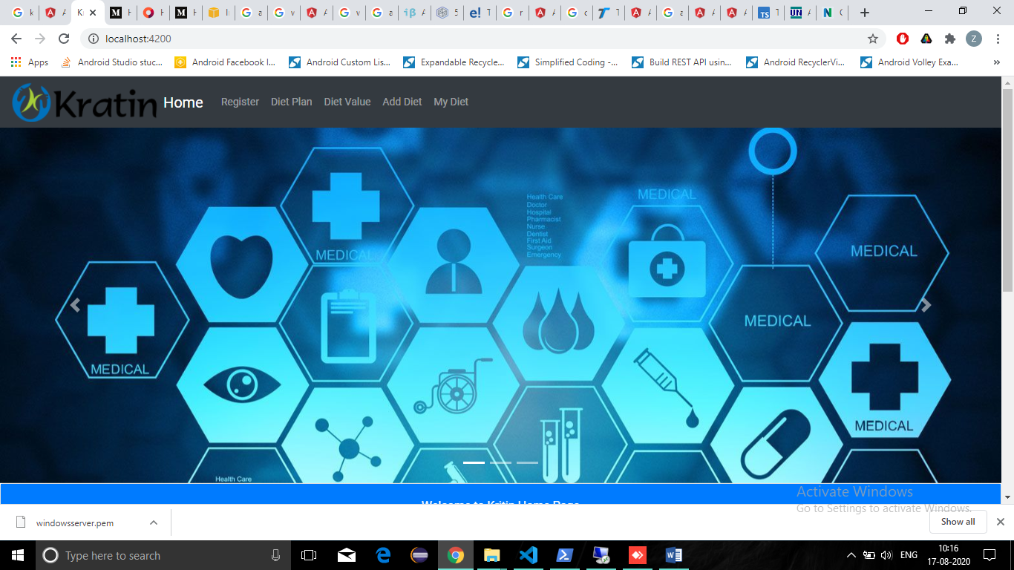

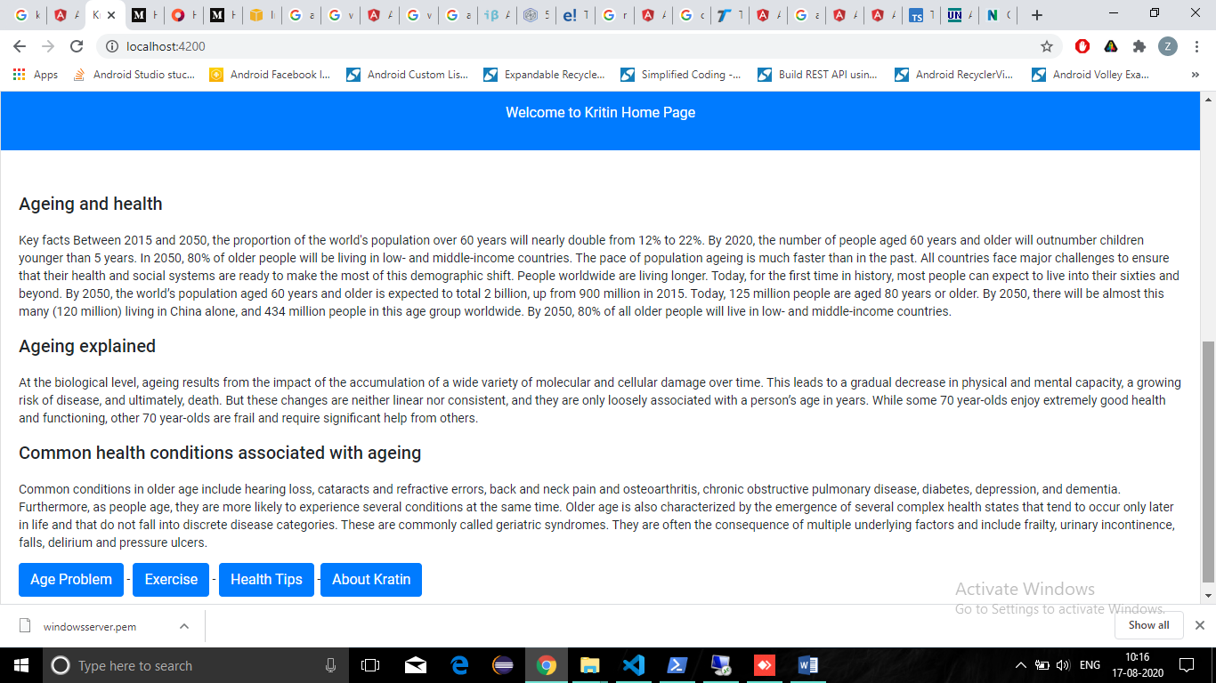

The home page contain the detail of the disease, the age problem, exercise, health care, common health condition associated with ageing.

The button contain the useful information which shows the video and website required.

1. **Register Page**

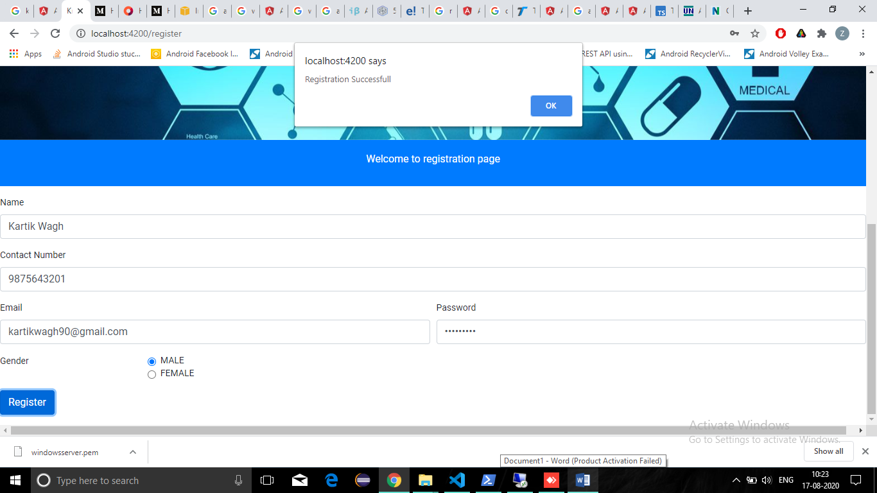

The registration page contain various fields that are required for registration.

1. **Diet Plan**

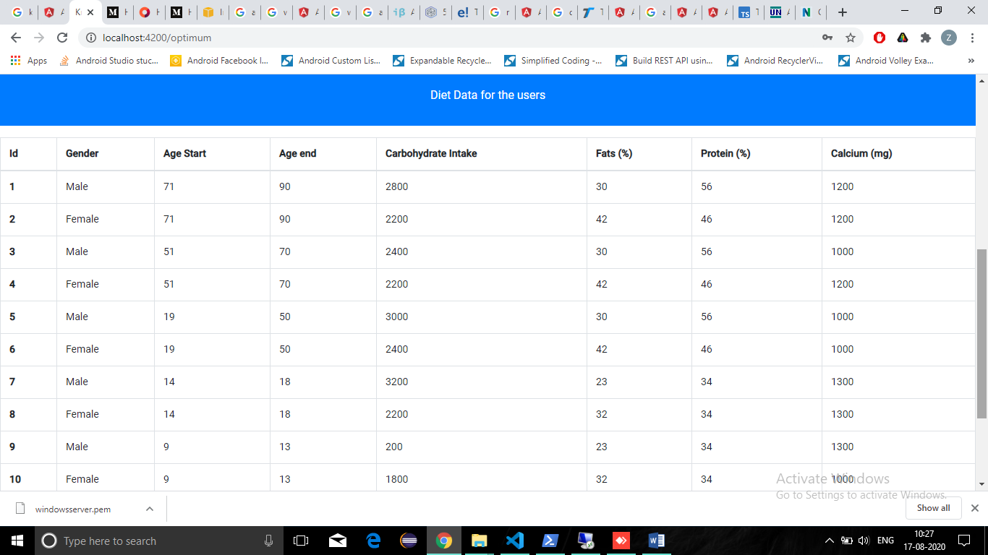

The diet plan contain all the information of protein, calcium, fats, etc. that are required in human body in different sex depending on the different ages of human being.

1. **Diet Value**

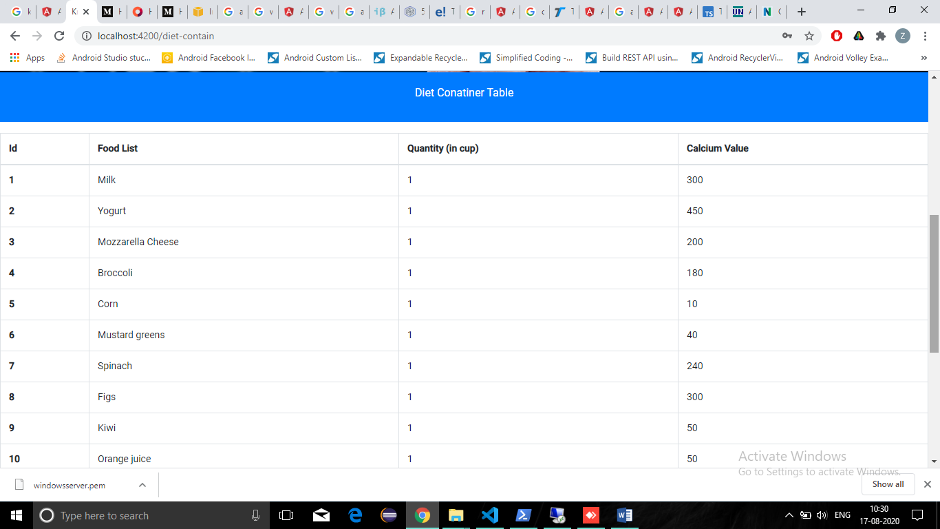

The diet value contain the detail of the food and the amount of calcium that it contain.

1. **Add Diet**

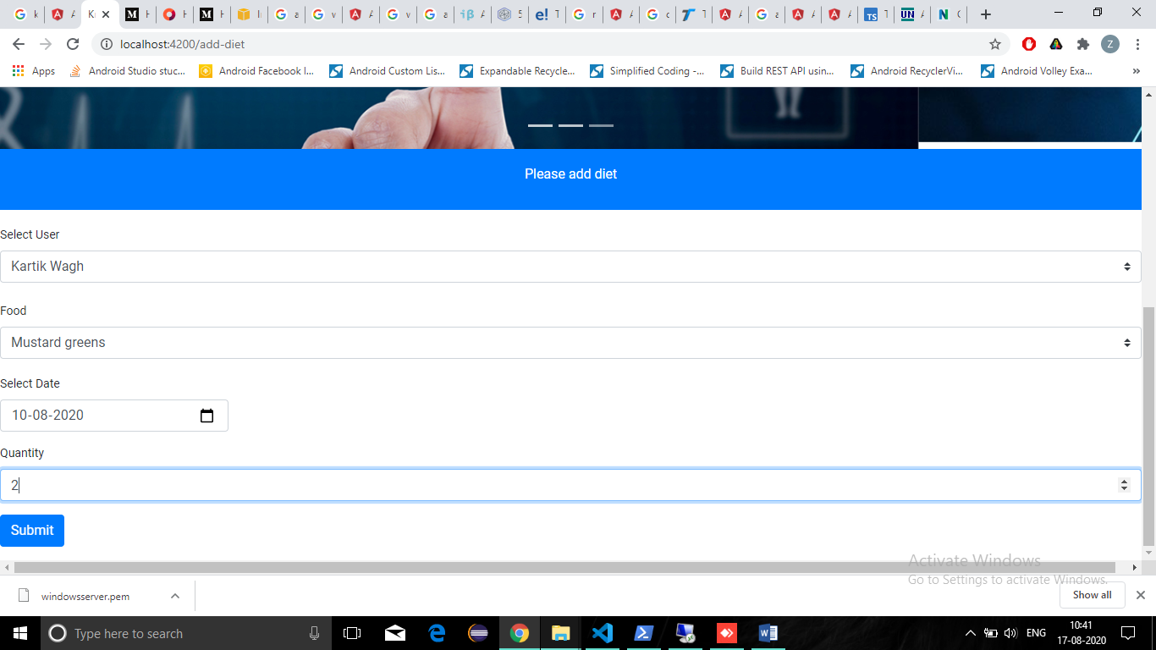

The add diet page is used to add the diet for the user to calculate the amount of calcium that they have consumed per day depending on the quantity and the name of the food that they have consumed.

1. **My diet**

The My diet page contain the chart that is used to show the total amount of calcium consumed per day. The chart is made from angular chart js.

The user have to select their name and click on submit button. By doing so the my diet page will show them the amount of calcium they have consumed per day.

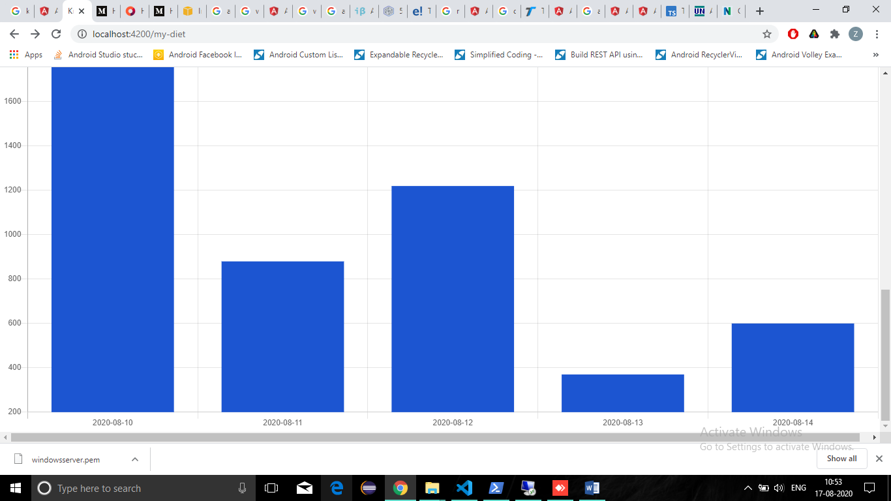

Diet Value

Diet_value_id(pk)

Food:string

Value:number

…….

…….

…..

Diet Plan

Diet_plan_id (pk)

Gender:string

Age_start:number

Age_end(number)

……….

…………

.

Register

Register_id (pk)

Name:string

Contact_no:string

Email_id:string

Password:string

Gender:string

My diet

My_diet_id(pk)

Register_id (fk)

Add Diet

Add_diet_id (pk)

Register_id (fk)

Food:string

…….

….

Data base scheme of the application.

**Technology used:**

Angular 8, Spring boot (STS) ,My SQL Workbench.

Github Link: (Source Code)

<https://github.com/zaveriakulsoom/kratinapplication>

Application Host

http://3.129.146.144/